Draft Corporate Plan 2015-19 and Draft Budget 2015-19

Final Consultation Report (as of 3rd February 2015)

Consultation on the draft Corporate Plan 2015-19 and draft Budget 2015-19 opened on 24th December 2014 and closed on 31st January 2015.

The consultation was available on our website and a paper copy was published in the Oxford Mail on Wednesday 7th January 2015. Paper copies were available on request from consultation officers in the Town Hall.

A total of 60 people responded, of which 36 online, 23 via the Oxford Mail, and one submission by email from Councillor Ian Hudspeth that is presented at the end of this report. Comments have been taken verbatim (i.e. typos have not been corrected).

Survey responses

Draft Corporate Plan 2015 – 19.
Respondents ranked the five corporate priorities in priority order. The number in brackets is the total of the scores that respondents gave to each priority (4 for the highest priority and 0 for the lowest) – the higher the number, the higher the priority.

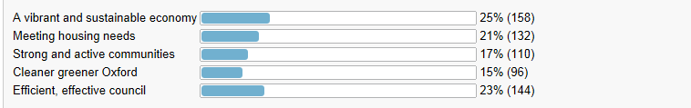
This was difficult to answer! What is a 'vibrant' economy? Or an 'effective' council? Terms like these mean different things to different people. I would like an economy that focusses on stability and quality of life rather than growth but cannot see how to indicate that as my top priority.
Don't see why these aims should be in competition for priority! And surely they are mutually reinforcing?
Effective budget management needs to be a key part of the plan.
The way to generate growth in the Oxford economy is to promote business. This would be greatly facilitated by sensible transport and parking policies, noticeably lacking at present. People will not come into town for any reason - shopping, work or leisure if it is impossible or prohibitively expensive to park and nor will they use the Park and Rides if the cost of doing so is too high. Charging to park at park and rides is clearly stupid if the aim is to encourage people to use them and there is an argument for free bus travel into the city from them as well. Until the Council realises this then people will continue to visit out of town locations, other towns or simply not bother to go into Oxford at all.
Yes, they are the right priorities. But it's impossible to seperate these into a 0-4 ranking. They are so interlinked and it would be hard to achieve them individually and independently.
Yes, I think they are the correct priorities for the council
If 14% if the city's population leave school with no qualifications then education should be a priority, when I have done temping and part time work eg in shops I have actually been quite shocked at how some of the school leavers struggle with basic reading, writing, (and these are not people that have been diagnosed with dyslexia) not being able to collect the correct click and collect orders for customers! We also have postal staff that struggle to place the letters in the correct houses.

2. New and Ongoing Investment
The City Council's Corporate Plan and Budget 2015 -19 set out its support for a number of investment proposals – some made in previous years and some new. The most significant are listed below. Please indicate whether you agree or disagree with the proposals.

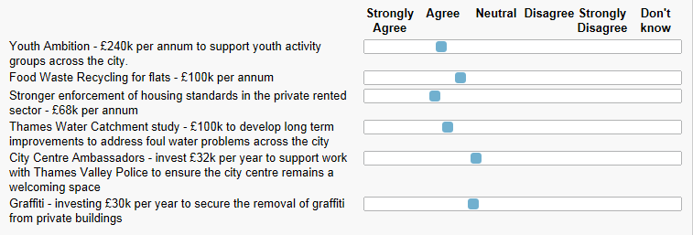

Thames Water should be fully funding the foul water problems. That's why we pay water rates. Instead they syphon off profits rather than investing in essential public health infrastructure
Also please invest in ensuring the city centre is clear of discarded litter and 'chuggers' (charity muggers)
Use the CCTV technology available to catch and arrest those graffiti vandals. Keep a tighter surveillance on susceptible private building. It will save thousands of pounds.
Graffitti tends to appear in more derelect areas in general, perhaps trying to improve the envrionment through grants etc, better shop frontings could potentially reduce the need for people to want to graffitti.
The cost of removing graffiti the Council should try to recover some of the costs from prosecutions and private building owners where possible
WHY TAXPAYERS MONEY TO REMOVE GRAFFITI FROM PRIVATE BUILDINGS ?????
IS PRIVATE MONEY USED TO REMOVE GRAFFITI FROM COUNCIL BUILDINGS ? OF COURSE NOT........ IDIOCY

3. Capital Investment
The Council proposes capital investment in the areas shown below. Please let us know if you agree or disagree with the proposals.

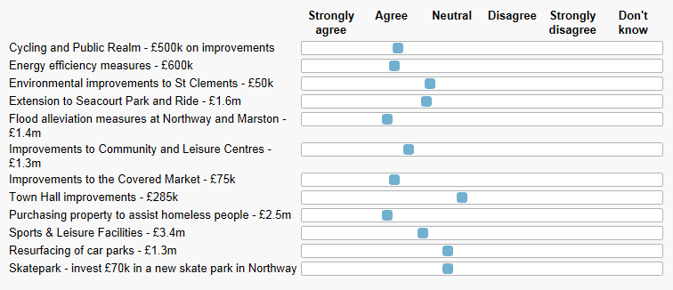

Energy efficiency measures must have a clear cost/benefit analysis and produce a decent return.
Also try and find some way of working with the County Council to extend Water Eaton Park and Ride ahead of the new station opening there; it would also be good to see improvements to Frideswide Square to make it more welcoming for visitors to the city
If you are planing to invest £3.4m in Sports and Leisure Facilities, then why have you shut down the Temple Cowley swimming pool?
That swimming pool was easily accessed/used by local people and it was an asset for the community. Blackbirds Leys pool is completely out of range and it is served only by 2 buses.
Not enough leisure activities in Oxford. New pool in Blackbird Leys is a start but not enough for families. Too much has already been spent on cycling initiatives. Use the money to increase car parking and reduce car parking charges. Not everyone can or wants to cycle to live in Oxford.
You won't get much property to 'assist' the homeless for £2.5m, and housing them in better than bedsits or dormitory-like accommodation may not be the assistance they really need.
MAKE SURE WE ASSIST HOMELESS PEOPLE PRICED OUT BY GREEDY LANDLORDS HIGH RENTS.
FAIR REGISTERED RENTS SHOULD BE BROUGHT BACK.
A LIMIT ON HOW MANY DOMESTIC PROPERTIES THAT AN INDIVIDUAL CAN LEGALLY OWN.
Very supportive of making Oxford more accessible, with better facilities; particularly enthused by the covered market scheme

4. Housing Revenue Account
The following is a list of the main proposals in Oxford City Council’s Housing Revenue Account. This is a ring-fenced account that provides the management and maintenance services to council house tenants. Please indicate whether you agree or disagree with these proposals.
Note that six responders are council house tenants.

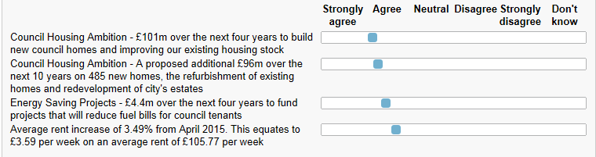

5. Fees and Charges
While the Council proposes that most charges such as those for garden waste, building control and planning and will remain at 2014 -15 prices, its draft Medium Term Financial Strategy does propose to increase some fees and charges over the next four years. Please indicate whether you agree or disagree with the following specific proposals:

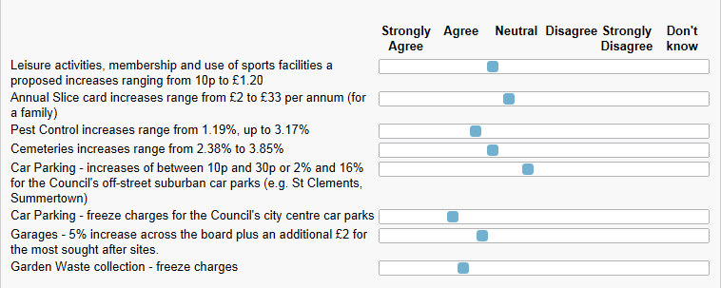

6. Council Tax
Income generated from Council Tax is used to pay for all services except those related to the management and maintenance of council dwellings. It covers, for example, street cleansing, refuse collection and park maintenance.

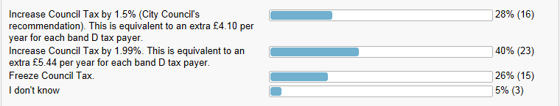

7. Council Tax Support Scheme
The City Council is recommending that its Council Tax Support Scheme (formerly the Council Tax Benefit Scheme) is maintained on the same basis as that introduced on 1st April 2013. It is estimated that this will cost the Council an additional £200k per annum. This means that people on very low incomes will continue to have part or all of their Council Tax paid. Do you agree or disagree with this proposal?

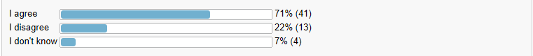

8. Other Comments
I appreciate that there are huge pressures to provide large amounts of new housing, and this seems to be 90% of the Strategy. However, there should be a corresponding emphasis on infrastructure improvement - the only significant item I can find here is Evergreen 3 but that is not enough (and will itself add to road traffic in a difficult area). Something must be done to improve access to the JR hospital before Barton Park is built. A new slip road from the A40 onto the A43 is a minimal requirement before the Northern Gateway is developed. And so on. There is also (paradoxically) the need to protect the open spaces which make Oxford a pleasant place to live, and this aspect receives only lip service in the plan. The overall effect is a kind of fait accompli in which there will be huge housing developments with scant regard for the negative impact on the city and its inhabitants.
investment needed into our green spaces and parks, investment to make oxford a better place to visit, increase its viberent look with floral displays to give a feel good factor to visitors
Non of the questions above made reference to ways in which the council could become more effective and efficient, and therefore enabling a more intelligent and effective way to run the council and spend tax payers money.
small point and perhaps a bit inconsequential but I find it unjust that both Headington car parks have a minimum charge of two hours when none of the other city car parks do!
The Council Tax should be paid by the home owner and not by tenants.
The rent in Oxford is unbearable high and on top of that, we have to pay among other bills, the Council Tax. This tax should be paid by who owns the house, because if the owner is paying a mortgage to a bank, the price of a rented house is the around the double of what the owner pays to the bank. If the landlord completely owns the house, then the rent price by consequence should be lower.
Football pitches just under 3% increase is not justified to encourage active communities when inflation at 1%
In addition to these proposals may I suggest that you reduce the number of councillors both at city and county council levels. There are far too many and a major cost saving could be made
Dear Sir
Re John Prices letter in Mail. ("Can the brightest brains put drain in right place?" Oxford Mail 7/1/15) In Cassington many years ago some bright brains when relaying the pavement saw a land pipe which they could not see any use, so they smashed it, not asking local views. They then put in drains in place (of) it, but about an inch above road level so when we get some heavy rain it floods to the height of the new drains while the ditch remains dry. when you report it they send somebody to look, not in the winter, but in the summer! so no problem then.
'An efficient and effective council': there's room for improvement there and at little or no expense.For a start, how about getting the Communities, HMO Licensing and Planning staff together to come up with common standards for the change of single household dwellings to HMOs so that the advice they give the public isn't contradictory? Premises above shops that used to be occupied by families back in the 18th, 19th and early 20th centuries should not necessarily be regarded as family homes today, as they do not provide suitable family accommodation.
Only 952 new council homes? All the more reason to make sure that none of our existing council homes is being occupied/subsidised illegally.
LONG TERM SURVEYS CAN INCLUDE ALL COUNCIL TAX PAYERS BY INCLUDING SURVEY FORMS WITH COUNCIL MAIL SHOTS WITH MINIMAL COST AS THOSE MAILSHOTS ARE SENT OUT ANYWAY.
road repairs need to be escallated for mor estate roads and rural areas not just concentrating on the main routes.
Why when candidates for election as councillor come to canvass do they never talk about thsese issues?
I remain concerned by the impact of new housing upon the character and charm of Oxford. A balance must be sought, to build new homes where infrastructure already exists, or can be upgraded, vs. eating at the edges, and turning Oxford into a larger sprawl of houses. We must keep in mind the impact of more concrete on the water drainage cycle in the Oxford area - not building on flood plains is obvious, but not building in areas that will then impact water run-off and so impact housing via secondary means must also be considered.
With respect to infrastructure, the current ring road is already at maximum capacity during rush-hour, the traffic in and out of Oxford on Botley Road, London Road, etc. is high. I understand the argument that more housing will lower commuting and impact on the road systems, but the prospect that people will live sufficently close to where they work that they will not need to commute is low. The UK is a nation of house and car owners; we like to drive!
I can only commend the regenerations of, e.g., Westgate and Covered Market; this will bring more people into Oxford, make it more appealing to visit. Start there, reinforce and upgrade what exists, build extra houses on brown field sites, regenertae Barton. Then look to whether expansion is feasible, considering the environmental impacts, necessary, and desired.
I would be interested in more information on the apprenticeship schemes and the building plans for east oxford.

Oxfordshire County Council Response to Oxford City Council’s Draft Corporate Plan and Draft Budget 2015-19
Introduction
Oxfordshire County Council welcomes the opportunity to comment on the City Council’s draft Corporate Plan and Budget for 2015-19.
As the budget proposals outline we do of course recognise that the financial outlook for Local Government continues to look very bleak and we regard the City Council’s approach to future financial planning as shrewd preparation for the potential loss of government grants to local authorities.
The Corporate Plan is a bold vision for the future shaping of the city and there are a number of strategic objectives that support the county council’s own ambition for a thriving Oxfordshire and we look forward to working in partnership with the City Council to develop and deliver these objectives.
In the context of shrinking financial support from central government we appreciate the commitment from the City Council to continue to safeguard the most vulnerable from cuts in services aligning with the county council’s own policy position to provide a safety net.
There are some areas of the documents presented for which we would like to provide detailed feedback, we have also included suggestions for other areas of collaborative working the City Council may wish explore to help achieve the priorities set out in the Corporate Plan.
Specific Comments
Council Tax
We understand that the proposals are still in draft but would note that the current assumption for a 1.5% increase in Council Tax does not line up with either the assumption made in the county council’s draft Medium Term Financial Strategy 2015/16 to 2017/18 for a 1% increase, or the referendum limit of 1.99%. We will continue to liaise closely with colleagues at the city and districts councils on this matter.
Oxfordshire Pool Arrangements
On the complex issue of business rate pooling we have actively supported pooling arrangements as a means of minimising the amount of ‘levy’ on the business rates growth in Oxfordshire that is paid by our districts to the government. Pooling also encourages us to work together on understanding the system, on growth issues and on sharing the risks arising from localised business rate income.
For technical reasons, levy payments in Oxfordshire can be minimised by restricting the number of our districts that are in the pool. We recognise that this means some districts who might benefit from being in the pool will not benefit. Therefore we are working with the city and all of the district councils to find fair ways of distributing both the benefits, and the risks of pooling, to all our districts.
Economic Growth & Regeneration
We agree that partnership working between the two authorities and across Oxfordshire has improved considerably in recent years as a consequence of the joint commitment to economic growth that has borne fruit though the resources drawn in through the City Deal and more recently the Local Growth Deal.
Having pressed for the establishment of the joint statutory committee, now the Oxfordshire Growth Board, it is perhaps a little surprising that there is scant mention of the opportunity to elect support from this quarter for the ambition set out in the City’s Corporate Plan.
The county council is committed to playing its part in the collaborative approach set out and will strive to continue to actively support those strategic place shaping initiatives detailed in the Corporate Plan: Barton, Westgate, Northern Gateway, Headington, Oxpens and Oxford Station. We are also happy to work with the City Council in their new approach to neighbourhood management in the most deprived communities where a new approach is being trialled.
Community Infrastructure Levy (CIL)
There has also been strong collaborative working in the introduction of the CIL in the city and the development of a charging schedule and joint programme of investment in infrastructure. However, there is some confusion in the figures presented in the report and recently circulated to the county council. In the Budget Strategy report, the figure for county led schemes detailed in paragraph 75 is £2.1 over the four period whereas the figures under ‘new bids’ in Table 9 is £3.38m over the same period and figures recently presented to the county council details just £500k over the same period. We would seek some urgent clarification on the definitive figure for infrastructure investment given its key role in supporting economic growth.
Meeting Housing Needs
The county council has already provided detailed feedback on the City Council’s draft housing strategy for 2015-2018 and recognise the challenge the facing the city in meeting the expectations of the Strategic Housing Market Assessment. Whilst we welcome the commitment to ensuring more affordable homes are built in the city, given the stagnation in recent years, there is a perceived over emphasis on the provision of retained housing stock. We would seek a stronger commitment from the local planning authority to encouraging affordable development that maximises net additions to overall housing stock in the city, while ensuring appropriate developer contributions to supporting infrastructure.
In the ‘Reducing homelessness’ section, we applaud the City’s efforts on reducing the number of homeless families living in temporary accommodation, but again would welcome recognition of the well-established partnership work with the county council and this cohort in the Plan.
Skills Agenda
We share the belief that ‘Improving the skills of the workforce’ is an important goal. However, the role of the county council, particularly as the Local Education Authority and statutory authority for children’s social services, needs to be recognised and highlighted in this Plan. To put our activity in context, in 2014/15 we spent over £100m on education and early intervention services in the county.
We are encouraged that the City Council is engaging with this cohort but would welcome recognition in the Corporate Plan of the substantial partnership working that is already happening with the county council and want to reiterate our preference for coordination of
schemes and initiatives around schools, NEETs and apprenticeships. The provision of skills and educational services for the children and young people of Oxford needs to be joined-up for optimum outcomes to be achieved.
We believe the majority of the items included in the list on page 15 (‘Oxford City Council is’) need the addition of ‘in partnership with the county council’.
Strong, Active Communities
This ambition is also an important tenet of the county council’s own Corporate Plan. Enabling people to become more empowered and proactive is crucial to the city achieving its full potential. We are surprised that the facts chosen to introduce this section reflect a broadly negative picture: Oxford’s population has the highest level of qualifications in the county and six times more of Oxford’s population live in Lower Super Output Areas (LSOAs) ranked in the highest decile i.e. the areas least deprived in the country, than those that live in the LSOA ranked in the lowest decile in the country. While we share the aim of focussing services on the most vulnerable and deprived groups, the county council feel it is important to recognise the existing strength of our communities and make the most of the affluence and educational attainment in the city as it represents an invaluable resource through which communities can thrive.
Youth Ambition
In the ‘Promoting youth ambition’ section the county council echoes the desire to help young people have positive life opportunities. Again, we ask for recognition of the scale of the work that the county council engages in around this ambition in the city, even where budget reductions are taken into account. We feel it is important to make clear that the county council is the lead authority for children’s service and education and is the home of the Youth Offending Service and Public Health directorate. We welcome the City Council’s interest around provision of services for young people, and strongly support the need for a coordinated response – this is crucial if we are to deliver the best outcomes for our young people. Our commitment to joint working is evidenced through the Working Together agreement we have recently signed with the City Council and we would ask for acknowledgment of this.
Schools
The ‘Strong Financial Management’ section, provides a robust response to central government funding reductions and initiatives. For the county council (which is also significantly impacted), these changes serve to increase the need and importance of partnership working. The county council queries why schools are mentioned here, as schools funding has not reduced (indeed, schools funding is not part of the City Council’s budget setting). We also query why ‘services for young people outside the school environment’ are singled out. As the lead authority for children’s service and education the county council is committed to serving the needs of this cohort. If the City Council has particular concerns about these services in Oxford we welcome its feedback which we will always take it into consideration. As stated above, the county council is committed to working with all partners to improve outcomes for our young people.
Older People
We are pleased that the City Council is committed to ‘Supporting older people’. As the lead organisation in relation to adult care services in the city, the county council is absolutely committed to working with the City Council to deliver better outcomes for this group. This is true particularly around housing where there is a continuing need for the City Council to consider adequate Older People’s Housing in plans for any new housing developments, as
well as around their provision of leisure facilities and activities around broader community engagement.
Collaborative Working Opportunities
We believe the ambition for ‘a clear preference of in-house provision’ does not reflect the most realistic and efficient means of delivering the strategic objectives of the Corporate Plan and may constrain the opportunities to offer improved services to residents. The creation of the development partnership at Barton seems to contradict this stance and, as demonstrated there, constructive working with the private sector could bring much needed investment into the city. From our own experience, having an experienced highways delivery partner has enabled us to be fleet of foot and deliver the accelerated infrastructure investment required through City Deal.
We believe there is potential for the City Council to explore further collaborative working opportunities that could help achieve the priorities of the Corporate Plan and benefit both authorities, including:
Asset Collaboration - with the pressure to reduce the operational footprint and associated energy and facilities management savings, there is a real opportunity to look at co-location and use of assets in a different way, e.g. conversion of operational sites to housing, providing a saving and meeting other key objectives of the Corporate Plan.
Recycling - With the Ardley Energy Recovery Facility now in operation there are opportunities for the county council as Waste Disposal Authority to assist the City Council as Waste Collection Authority to increase the recycling rate in the city from the current level of 46% to be more aligned with the countywide level of 60%, reducing landfill and improving recovery levels - thus supporting further savings. We will consider joint incentives on how best to do this in the coming year.
Voluntary and Community Sector - we would suggest there are opportunities for stronger collaborative working with ourselves in this area through co-design and co-commissioning of services. This would reflect the county council’s own policy of helping people to help themselves.
Conclusion
We are encouraged that significant elements of the City’s Corporate Plan reflect the priorities set out in the county council’s own Plan, particularly around promoting and supporting a vibrant sustainable economy and encouraging strong, active communities. We are committed to working in partnership with the City Council to achieve these ambitions.
Cllr Ian Hudspeth
Leader, Oxfordshire County Council
January 2015

Sadie Paige
3rd February 2015

